Choose the letter of the correct answer. For all questions, answer E is “None of the Above”

1. A famous poet once said, “All the world's a field trip, and all the kids in our class are merely guinea pigs." Count the number of consonants of these two sentences.

A.) 39 B.) 52 C.) 76 D.) 100 E.) NOTA

2. Wanda is making a pattern that goes: 1, 7, 13, 19, 25, 31... Find the sum of the next three terms.

A.) 19 B.) 119 C.) 129 D.) 130 E.) NOTA

3. Phoebe is passing out oxygen tanks for the class’ walk on the moon. She has twenty-eight tanks in all, but she needs help passing them out. She gives one-fourth of them to Carlos, two-thirds of what is left to Keesha, and five of the remaining tanks to Arnold. How many tanks does she have left?

A.) 2 B.) 8 C.) 9 D.) 10 E.) NOTA

4. The Magic School Bus is 12 yards long. How long is the school Bus in inches?

A.) 48 B.) 108 C.) 422 D.) 432 E.) NOTA

5. Arnold and Janet like to collect nickels they find on the sidewalk. The number of nickels they find throughout the week is as such: 5, 8, 10, 11, 12, 12, and 13. What is the sum of the mode and median of the number of nickels Arnold and Janet found?

A.) 1 B.) 18 C.) 22 D.) 23 E.) NOTA

6. The class decides to make Arnold cinnamon sugar cookies to make him feel better. The recipe calls for:
- 1 cup of butter
- 1 cup of sugar
- 1 cup of vegetable oil
- 2 eggs
- 3 ⅓ cups of flour
- 1 teaspoon of cinnamon
- I cup of chopped pecans
If the class decides to make two and one-half times more cookies than the recipe calls for, how many cups of flour will they need?

A.) 1 ¹/₃ B.) 5 ¹/₅ C.) 6 ¹/₆ D.) 6 ½ E.) NOTA

7. The Magic School Bus is going on a trip. Before it leaves though, it needs gas. If the bus needs 12 gallons of gas and one gallon of gas cost $2.50, how much money is needed to pay for gas?

A.) $6 B.) $14.50 C.) $24 D.) $30 E.) NOTA

8. Keesha arrives at school at 8:15 A.M. every morning. Dorothy Ann arrives at school fifteen minutes after this time everyday. One Friday, Keesha decides to come to school forty-five minutes early so she can feed the class frog, Bella. Dorothy Ann comes to school the same time she normal does. How many minutes later did Dorothy Ann arrive at school than Keesha on Friday?

A.) 15 min. B.) 30 min. C.) 45 min. D.) 60 min. E.) NOTA

9. Oh no! Bella, the class frog, has run away. The class now has to vote on what animal to have as the next class pet.
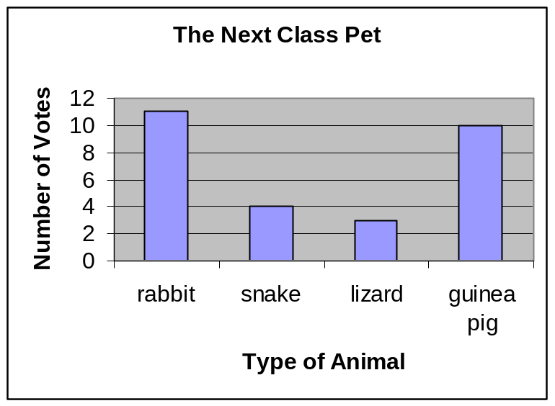
How many more people voted for a rabbit than a snake?

A. 1 B.) 6 C.) 7 D.) 8 E.) NOTA

10. Miss Frizzle’s class takes a test on the solar system. There are ten boys and sixteen girls in her class. Eighty percent of the boys and seventy-eight percent of the girls got a score of 95 or higher. How many boys and girls in the class got a score of 95 or higher? Round to the nearest whole number.


A.) 8 B.) 12 C.) 15 D.) 20 E.) NOTA

11. Janet takes 20 minutes to dress for school, 40 minutes to eat breakfast, 5 minutes to brush her teeth and 15 minutes to brush her hair. If Janet leaves the house at 8:00 every morning, at what time should she get up?

A.) 6:40 B.) 6:45 C.) 7:00 D.) 7:15 E.) NOTA

12. Carlos needs to get his gear for the class’ field trip to the beach. He can choose from five different swimming trunks, two kinds of goggles, seven kinds of sunscreen lotion, and three types of skim boards. How many different combinations of swimming trunks, goggles, sunscreen lotion, and skim boards can he make?

A.) 17 B.) 31 C.) 210 D.) 420 E.) NOTA

13. To get to her old school, Phoebe would have to walk five blocks west, seven blocks north, three blocks east, and two more blocks north. If one block equals three-quarters of a mile, how many miles would Phoebe have to walk to get to her old school?

A.) 5.78 B.) 17.75 C.)22.60 D.) 51.00 E.)NOTA

14. Arnold is older than Tim. Two boys are younger than Ralphie. Carlos is not the oldest. Carlos is younger than Tim. Who is the third oldest?

A.) Arnold B.)Carlos C.) Ralphie D.) Tim E.) NOTA

15. Wanda and Tim decide to race their pet frogs. They must cross a course of twenty-four lily pads. According to Dorothy Ann’s research, Wanda’s frog can jump two lily pads at a time and Tim’s frog can jump three lily pads at a time. How many more lily pads does Tim’s frog touch than Wanda’s frog when Tim’s frog lands on the 24th lily pad? Assume the frogs jump at the same time for every jump.
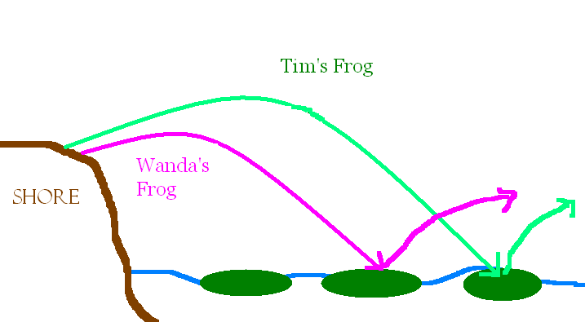

A.) 4 B.) 6 C.) 8 D.) 12 E.) NOTA

16. Miss Frizzle’s kitchen is in the shape of an octagon. Her living room is in the shape of hexagon. If her kitchen and living room both share one side, how many sides make up the perimeter of the kitchen and living room?

A.) 9 B.) 12 C.) 13 D.) 14 E.) NOTA

17. The class’ field trips are highly unusual. Once a year however, Miss Frizzle decides to do something normal for once and takes the class to the zoo. Adult (18 years and older) tickets are $7.50, older students (9 years and above) are $6.50, and younger students (under 9 years) are $5.00. How much would it cost to take Miss Frizzle and her class of nine younger students and nineteen older students to the zoo?
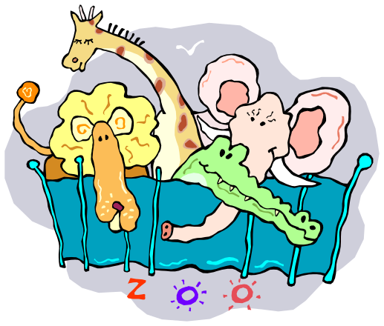

A.) $153.50 B.) $168.50

C.) $175.00 D.) $176.00

E.) NOTA

18. Dorothy Ann is doing research in the library. She opens a book and finds the sum of the facing pages is 147. What the product of the two page numbers?

A.) 5400 B.) 5402 C.) 21,025 D.) 21,609 E.) NOTA

19. Wanda finds a cool rock while hiking. She decides to weigh the rock and finds it weighs 7.9 pounds. How much is the rock’s weight in grams?

A.) 79 B.) 121.4 C.) 126.4 D.) 158 E.) NOTA.

20. To liven up the classroom, Miss Frizzle brings in an exotic plant from the Amazon. It needs at least three cups of water a day, excluding weekends, to stay alive. How many cups of water would the plant need in the month of April? (the first of April is a Sunday)

A.) 60 B.) 63 C.) 66 D.) 90 E.) NOTA

21. Phoebe, Wanda, Janet, and Keesha go shopping for a birthday present for Miss Frizzle. They buy earrings in the shape of lighthouses for $6.13, a pair of leather gloves for driving the bus for $15.65, a packet of hair pins for $3.20, and a bottle of John Frieda’s Frizz-Ease hair serum for $7.50. They pay with $50 and then split the remaining money among the four of them. How much money should each person have?

A.) $4.40 B.) $4.38 C.)$11.40 D.) $17.50 E.) NOTA

22. The Magic School Bus kids must solve this problem before the bus will let them back inside.
Find the remainder when 44,859,847 is divided by five.

A.) .29 B.) 2 C.) 3 D.) 5 E.) NOTA

23. Phoebe got to the bus late and now has to solve a problem all by herself before she can get inside.
Of these numbers, how many are prime? 17, 6, 1, 2, 89, 54, 73, 51

A.) 3 B.) 4 C.) 5 D.) 6 E.) NOTA

24. Miss Frizzle has decided to retile the classroom floor. Only tiles that tessellate can be used on the floor. Which of these designs is not a tessellation?
A.) B.) C.) D.)


E.) NOTA

25. Arnold and Janet are cousins. Arnold’s favorite number is ¹⁴/₃, while Janet’s favorite number is 5 ¹/₃. What is the relationship between these two numbers?

A.) ¹⁴/₃ > 5 ¹/₃ B.) ¹⁴/₃ < 5 ¹/₃ C.) ¹⁴/₃ = 5 ¹/₃ D.) ¹⁴/₃ x 5 ¹/₃ = 1 E.) NOTA

26. While searching for gold, Miss Frizzles’ class finds an abandoned diamond mine. According to Dorothy Ann’s research, diamonds are a girl’s best friend. If there are one hundred ten diamonds and all fifteen girls want diamonds, about how many can each girl get?

A.) 5 B.) 6 C.) 7 D.) 8 E.) NOTA

27. Arnold and Wanda are trying to decide where to go for today’s field trip. Arnold wants to go to the lunchroom where it is safe, but Wanda wants to go visit the creepy haunted house. They play a game of rock-paper-scissors to decide the argument. How many different combinations of rock, paper, or scissors could appear in the game? (For example, Arnold plays paper and Wanda plays scissors.)

A.) 6 B.) 7 C.) 8 D.) 9 E.) NOTA

28. Phoebe started the organization Students Against Desert Scarcity (S.A.D.S) to help animals living in the desert. She convinces everyone in her class of twenty-two to donate $4.10 each. If seventy-five percent of the money goes towards animal relief, how much of the money is spent for other things?

A.) $22.55 B.) $67.65 C.) $90.20 D.)$ 120.27 E.) NOTA

29. Dottie Frizzle, Miss Frizzle’s niece, comes to visit the class and her aunt every Friday. The first Friday she notices the height of the exotic Amazon plant is six inches. The second Friday it is ten inches tall. The third Friday it is 14 inches tall. If the plant continues to grow at this rate, what will its height be in inches the tenth Friday she visits?

A.) 36 B.) 38 C.) 42 D.) 46 E.) NOTA

30. Alli, Noli, and the other nine MAθ officers all gather together to watch the marathon of the Magic School Bus on T.V. Saturday afternoon. Nine officers prefer butter on their popcorn and seven like salt on their popcorn. Five officers like salt and butter on their popcorn. How many officers like to eat their popcorn with no butter or salt on it?

A.) 0 B.) 1 C.) 2 D.) 3 E.) NOTA



ANSWER KEY

- C
- C
- A
- D
- D
- E 
- D
- D
- C
- D
- A
- C
- E (12.75)
- D
- C
- B
- B
- B
- C
- B
- B
- B
- C
- D
- B
- C
- A
- A
- C
- A

